Name: _________________________
Density Graph
Examine the following graph and answer the questions that follow. (3 marks)

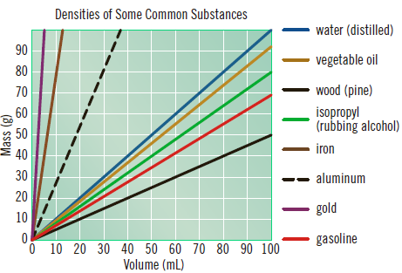

- What is the most dense substance on the graph? _____________________

- What is the least dense substance on the graph? _____________________

- Would aluminum sink or float in gasoline? __________________________

- Make up your own density question from the graph AND answer it.
(2 marks)

- Calculate the density of an iron nail with a volume of 10 cm³ and a mass of 80 g. Use the 5 steps! (5 marks)

